 | A |  |  |  |  | B |  |  |  |  | C |  |  |  |  | D |  |  |  |  | E |  |  |  | F
1 |  |  |  |  |  | 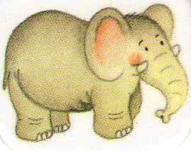 |  |  |  |  |  |  |  |  |  |  |  |  |  |  |  |  |  |  | 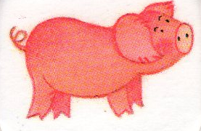
2 | 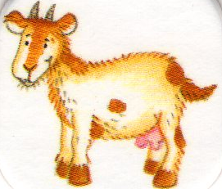 |  |  |  |  |  |  |  |  |  | 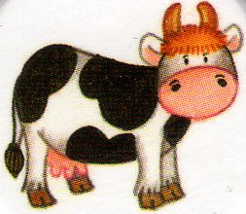 |  |  |  |  | 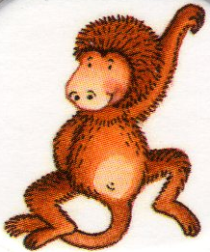
3 |  |  |  |  |  |  |  |  |  |  | 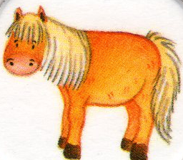
4 | 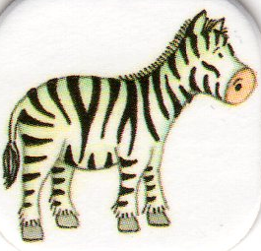
5 |  |  |  |  |  |  |  |  |  |  |  |  |  |  |  | 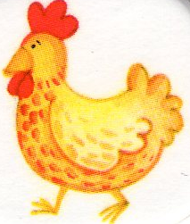
6 |  |  |  |  |  | 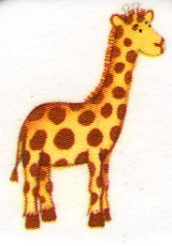 |  |  |  |  |  |  |  |  |  |  |  |  |  |  |  |  |  |  | 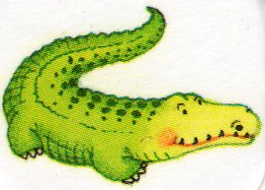
 | A |  |  |  |  | B |  |  |  |  | C |  |  |  |  | D |  |  |  |  | E |  |  |  | F
1
2
3
4
5
6
 | A |  |  |  |  | B |  |  |  |  | C |  |  |  |  | D |  |  |  |  | E |  |  |  | F
1
2
3
4
5
6
 | A |  |  |  |  | B |  |  |  |  | C |  |  |  |  | D |  |  |  |  | E |  |  |  | F
1
2
3
4
5
6
 | A |  |  |  |  | B |  |  |  |  | C |  |  |  |  | D |  |  |  |  | E |  |  |  | F
1
2
3
4
5
6
 | A |  |  |  |  | B |  |  |  |  | C |  |  |  |  | D |  |  |  |  | E |  |  |  | F
1
2
3
4
5
6
 | A |  |  |  |  | B |  |  |  |  | C |  |  |  |  | D |  |  |  |  | E |  |  |  | F
1
2
3
4
5
6
 | A |  |  |  |  | B |  |  |  |  | C |  |  |  |  | D |  |  |  |  | E |  |  |  | F
1
2
3
4
5
6
 |  | A |  |  |  |  | B |  |  |  |  | C |  |  |  |  | D |  |  |  |  | E |  |  |  | F
1
2
3
4
5
6
 |  |  | A |  |  |  |  | B |  |  |  |  | C |  |  |  |  | D |  |  |  |  |  | E |  | F
1
2
3
4
5
6
 |  |  |  | A |  |  |  |  | B |  |  |  |  |  | C |  |  |  |  | D |  |  |  | E |  | F
1
2
3
4
5
6
 |  |  |  |  | A |  |  |  |  | B |  |  |  | C |  |  |  |  | D |  |  |  | E |  |  | F
1
2
3
4
5
6

