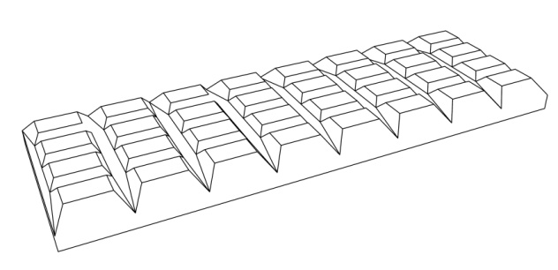

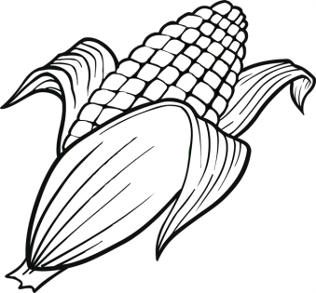
EVERYBODY WANTS TO EAT

Everybody’s hungry
Everybody’s eating
Everybody wants to eat
It’s delicious
Everybody’s hungry
Everybody’s eating
Everybody wants to eat
Everybody wants to eat

What’s delicious? Soup’s delicious
What’s delicious? Corn’s delicious
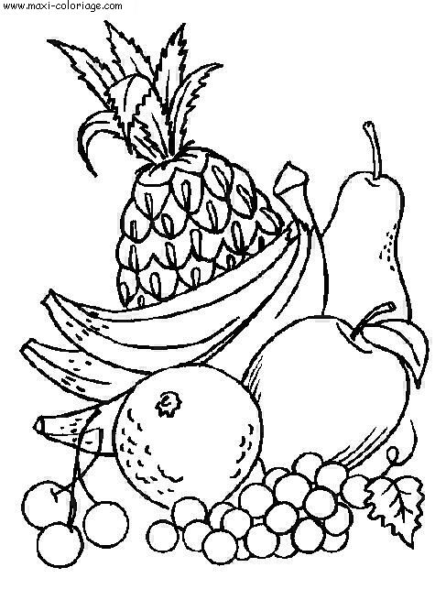
What’s delicious? Spaghetti’s delicious
What’s delicious? Milk, bananas, bread
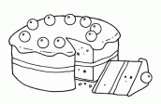
Everybody’s hungry
Everybody’s eating
Everybody wants to eat
It’s delicious
Everybody’s hungry
Everybody’s eating
Everybody wants to eat
Everybody wants to eat

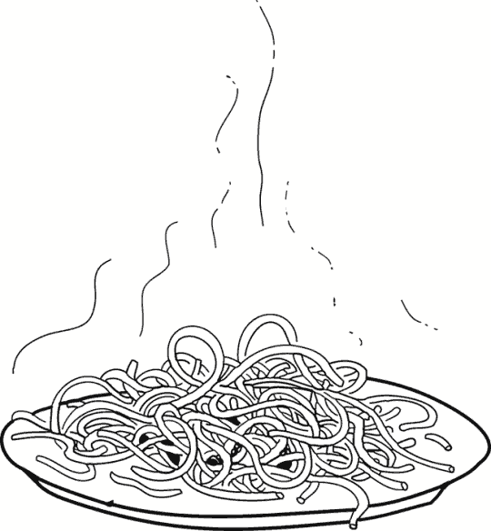
What’s delicious? Fruit’s delicious
What’s delicious? Cake’s delicious
What’s delicious? Chocolate’s delicious
What’s delicious? Milk, bananas, bread

Everybody wants to eat
Everybody wants to eat
Everybody wants to eat
Everybody wants to eat
