SEQUENCE ANIMALS

Material

ANIMALS LIENS SONGS VIDEOS
Old mac donald avec reprise énumérative
https://www.youtube.com/watch?v=hDt_MhIKpLM

cow, sheep, pig, duck, horse
2e version : plus d’animaux mais pas énumération
https://www.youtube.com/watch?v=LIWbUjHZFTw

chiks, cats, dogs, sheeps, cows, horses

album Brown bear
- Site bout de gomme – jeu bingo et eval de comprehension + video de l’album lu en anglais

ZOO
Song at the zoo
https://www.youtube.com/watch?v=oV_idfKcCdQ

SONG “Old MacDonald"
Old MacDonald had a farm,
Ee-i-ee-i-o,
And on this farm he had some chicks,
Ee-i-ee-i-o,
With a chick chick here, and a chick chick there,
Here a chick,there a chick, everywhere a chick chick;
Old MacDonald had a farm,
Ee-i-ee-i-o,
And on this farm he had some ducks,
Ee-i-ee-i-o,
With a quack-quack here, and a quack-quack there,
Here a quack, there a quack, everywhere a quack-quack;
Old MacDonald had a farm,
Ee-i-ee-i-o,
Old MacDonald had a farm,
Ee-i-ee-i-o,
And on his farm he had some cats,
Ee-i-ee-i-o,
With a meow meow here and a meow meow there
Here a meow, there a meow , everywhere a meow meow;
Old MacDonald had a farm,
Ee-i-ee-i-o.
Old MacDonald had a farm,
Ee-i-ee-i-o,
And on this farm he had some dogs,
Ee-i-ee-i-o,
With a bow-wow here, and a bow-wow there,
Here a bow, there a bow, everywhere a bow-wow;
Old MacDonald had a farm,
Ee-i-ee-i-o.
Old MacDonald had a farm,
Ee-i-ee-i-o,
And on his farm he had some sheeps,
Ee-i-ee-i-o,
With a baa-baa here and a baa-baa there
Here a baa, there a baa, everywhere a baa-baa;
Old MacDonald had a farm,
Ee-i-ee-i-o.
Old MacDonald had a farm,
Ee-i-ee-i-o,
And on his farm he had some pigs,
Ee-i-ee-i-o,
With an oink-oink here, and an oink-oink there,
Here an oink, there an oink , everywhere an oink-oink,
Old MacDonald had a farm,
Ee-i-ee-i-o
Old MacDonald had a farm,
Ee-i-ee-i-o,
And on his farm he had some cows,
Ee-i-ee-i-o,
With a moo-moo here, And a moo-moo there,
Here a moo, there a moo , everywhere a moo-moo,
Old MacDonald had a farm,
Ee-i-ee-i-o.
Old MacDonald had a farm,
Ee-i-ee-i-o,
And on his farm he had some horses,
Ee-i-ee-i-o,
With a neigh-neigh here and a neigh-neigh there
Here a neigh, there a neigh, everywhere a neigh-neigh;
Old MacDonald had a farm,
Ee-i-ee-i-o.
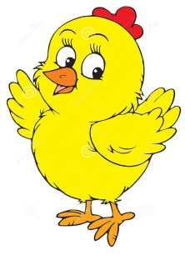

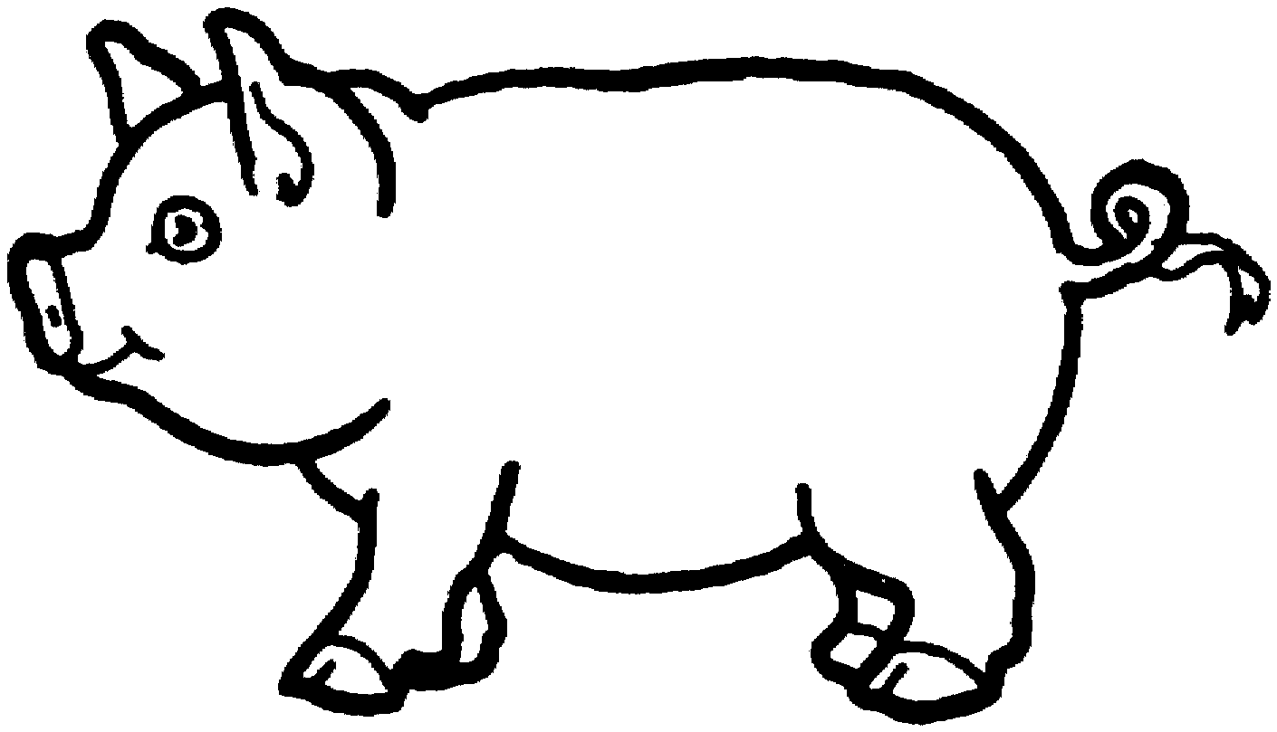

a bear | a duck | a frog | a sheep | a cow
a fish | a bird | a horse | a cat | a dog

a bear | a duck | a frog | a sheep | a cow
a fish | a bird | a horse | a cat | a dog

a bear | a duck | a frog | a sheep | a cow
a fish | a bird | a horse | a cat | a dog

a bear | a duck | a frog | a sheep | a cow
a fish | a bird | a horse | a cat | a dog

a bear | a duck | a frog | a sheep | a cow
a fish | a bird | a horse | a cat | a dog

a bear | a duck | a frog | a sheep | a cow
a fish | a bird | a horse | a cat | a dog

a bear | a duck | a frog | a sheep | a cow
a fish | a bird | a horse | a cat | a dog

