Listening guide

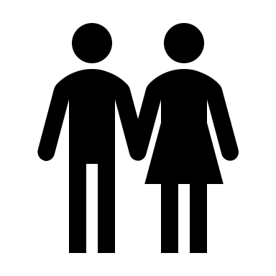
How many voices do you hear?

Where does the scene take place?

What are they talking about?

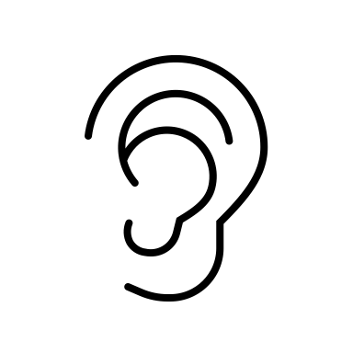
Pick out the words you are hearing:

Listening guide

How many voices do you hear?

Where does the scene take place?

What are they talking about?

Pick out the words you are hearing:

